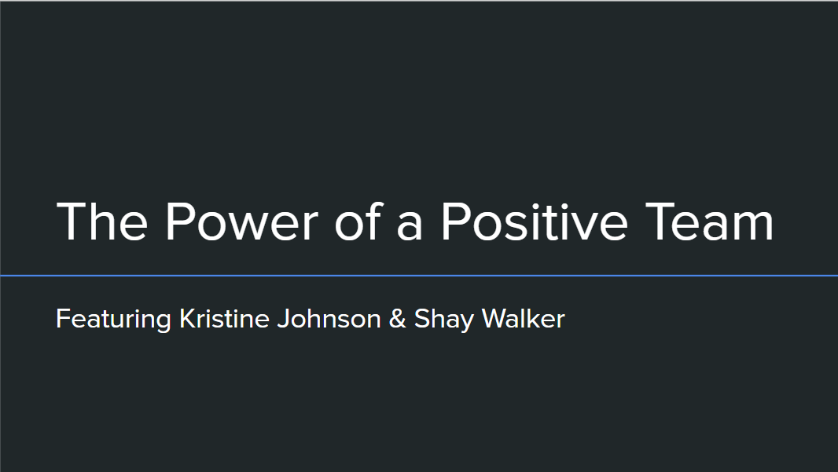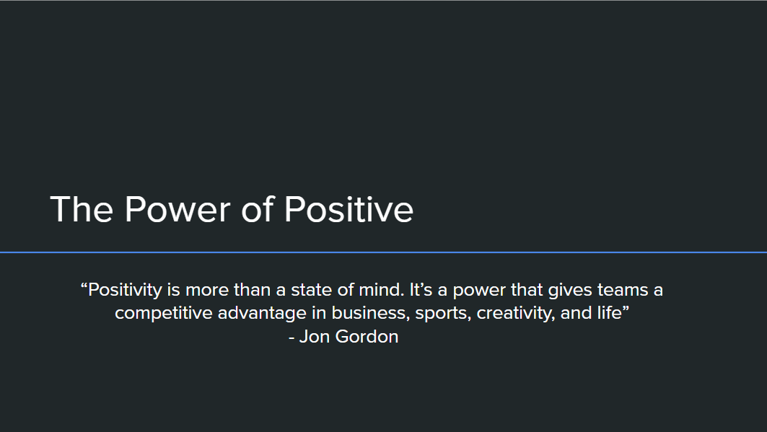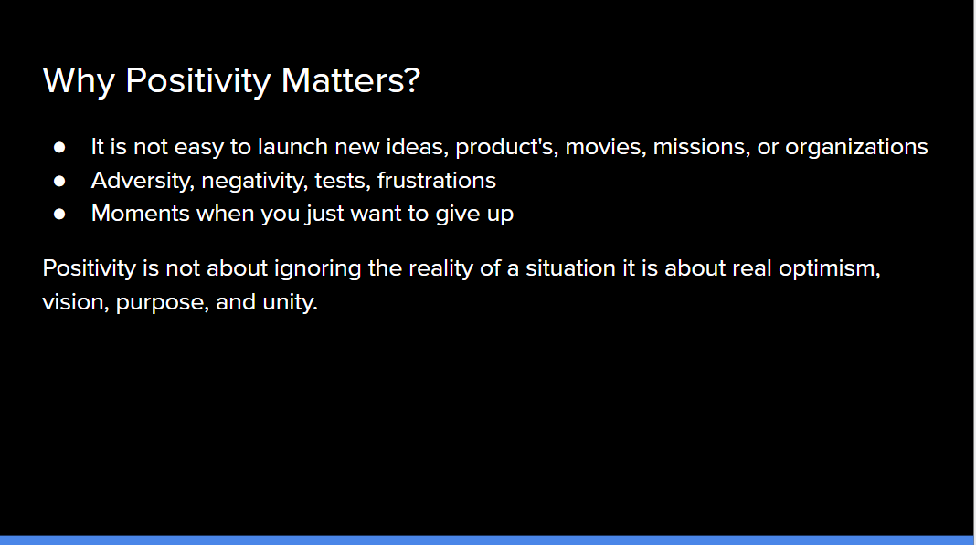

Instructions: Please follow along with the Note Packet and take notes for each section for each slide.

# No One Creates Success Alone

# 

# The Power of Positive

# 

# Why Positivity Matters?

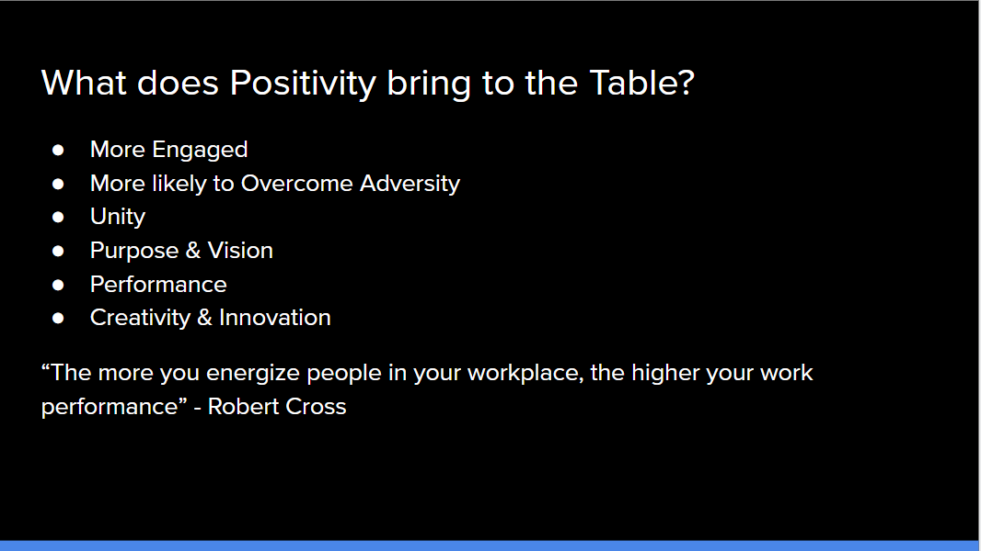

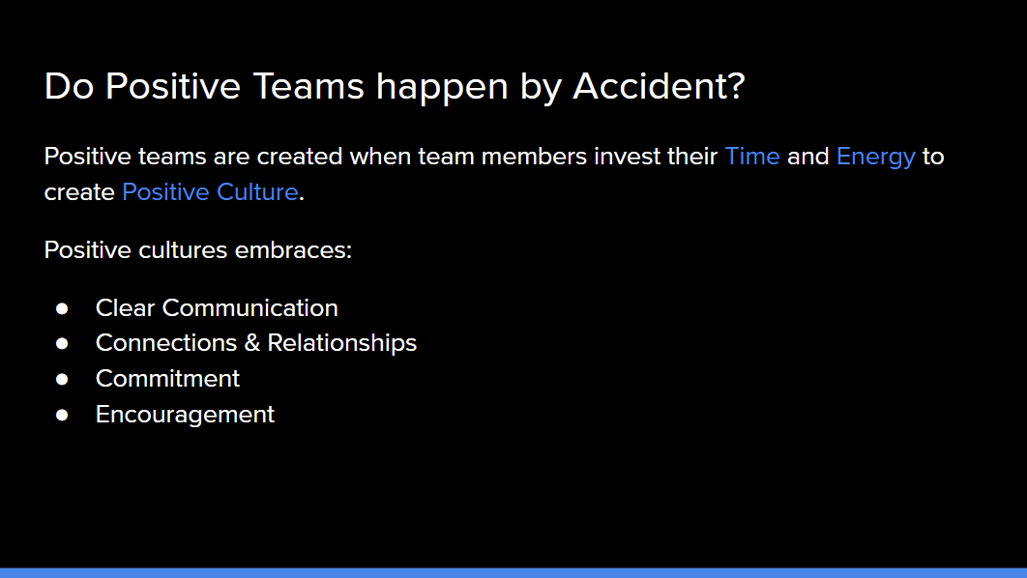

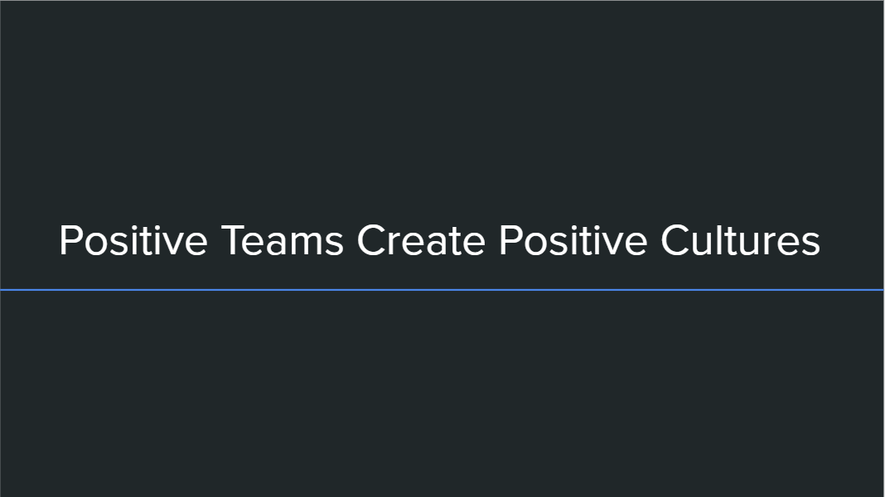

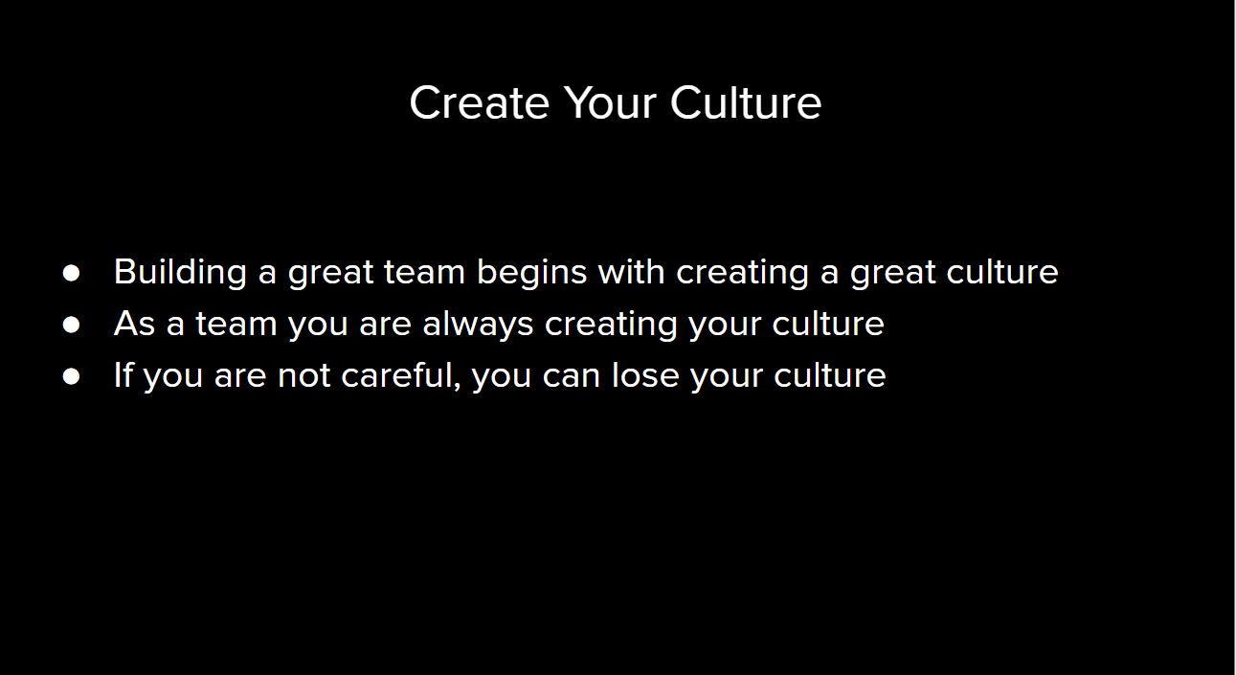

# What does Positivity Bring to the Table?

# Do Positive Teams happen by Accident?

# Positive Teams Create Positive Cultures

# 

# Create your Culture

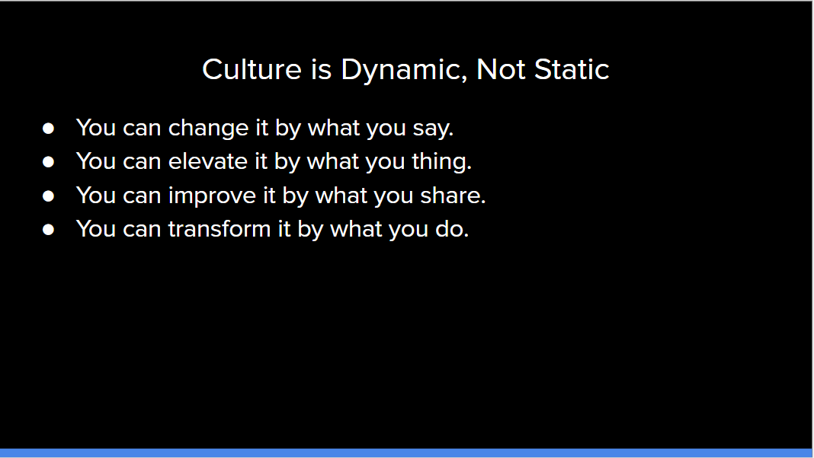

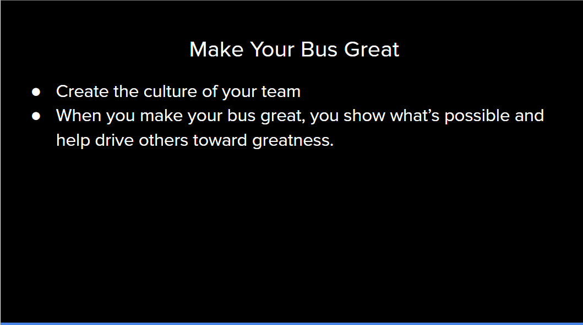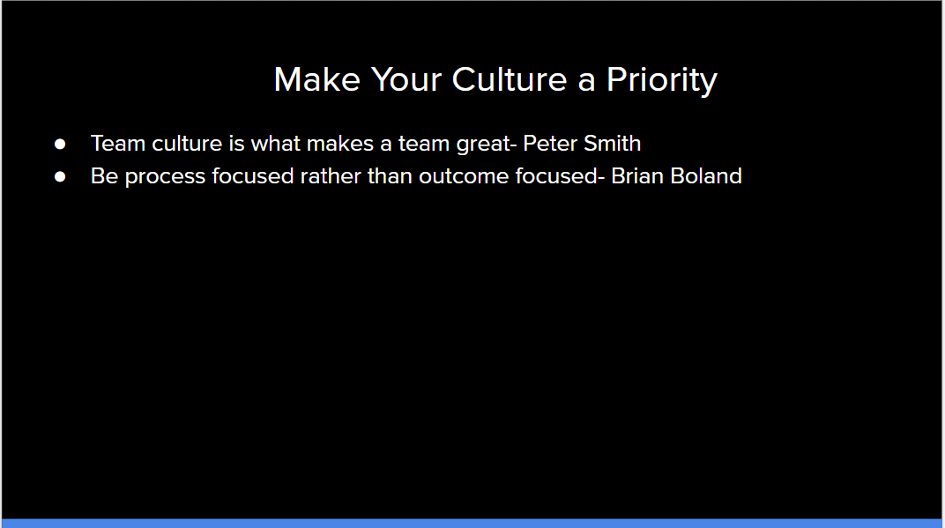

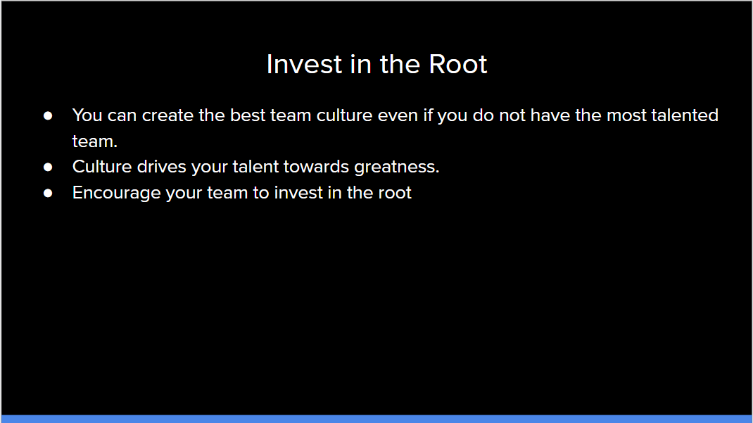

# Culture is Dynamic, Not Static

# 

# Make your Bus Great

# Make your Culture a Priority

# Invest in the Root

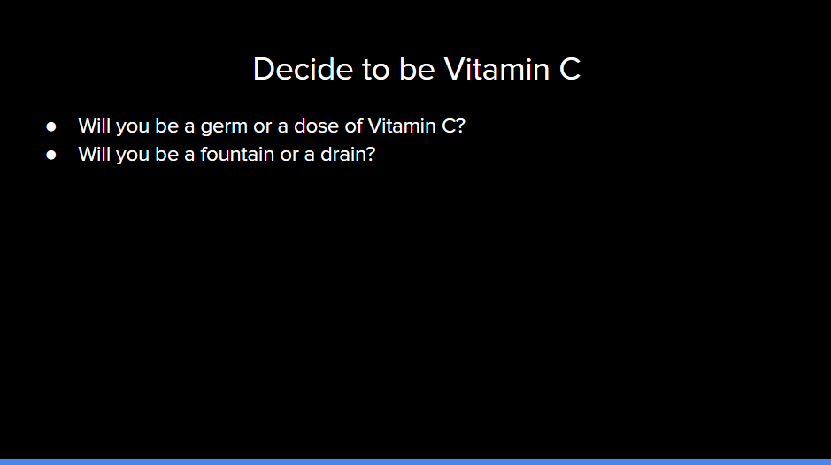

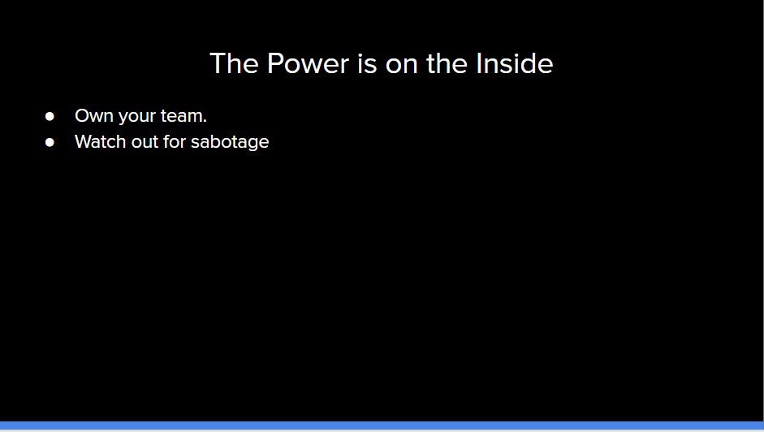

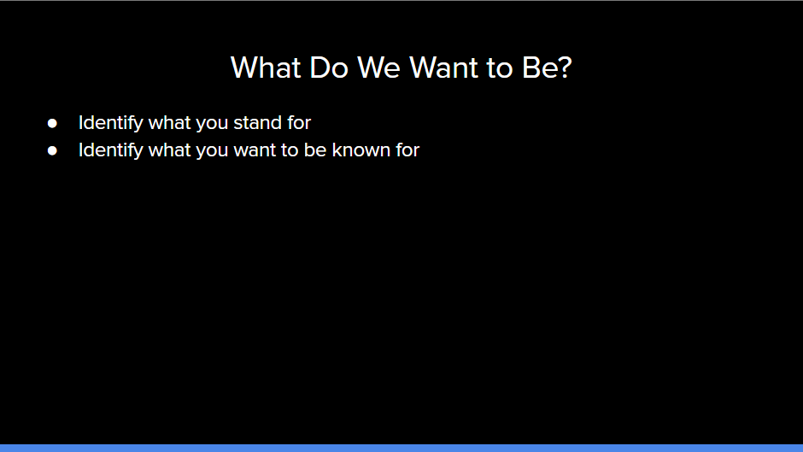

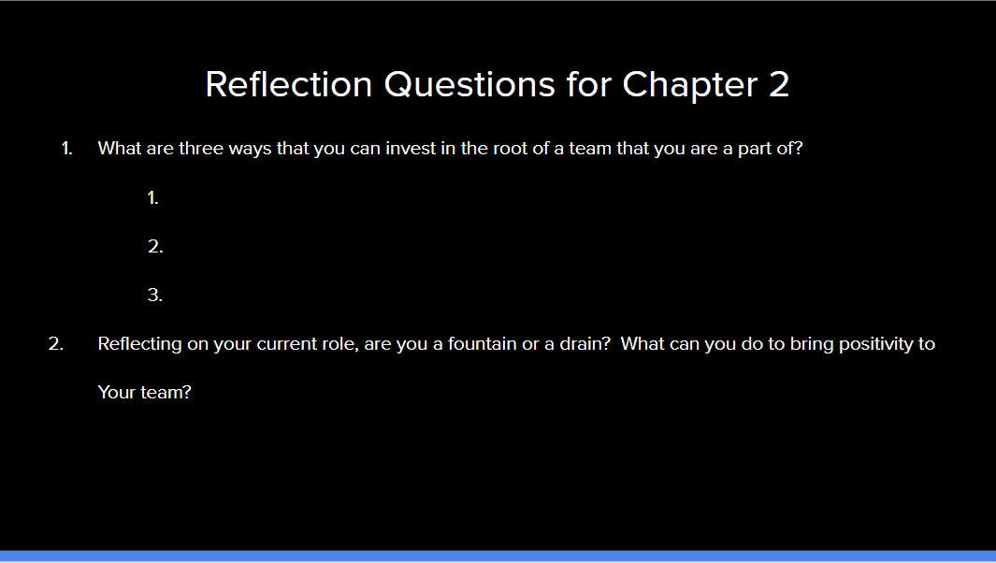

# Decide to be Vitamin C

# The Power is on the Inside

# 

# What Do We Want to Be?

# 

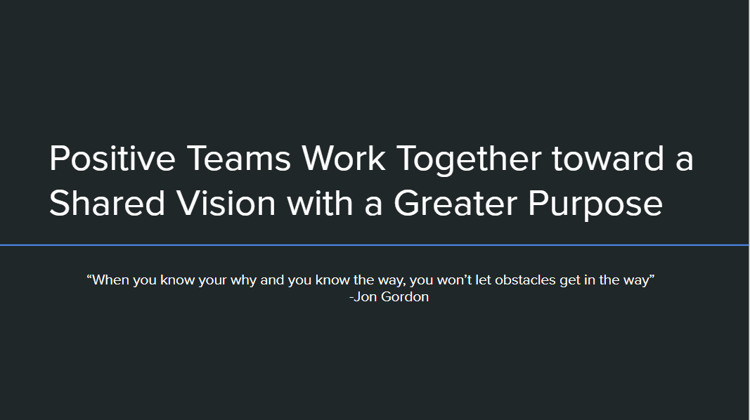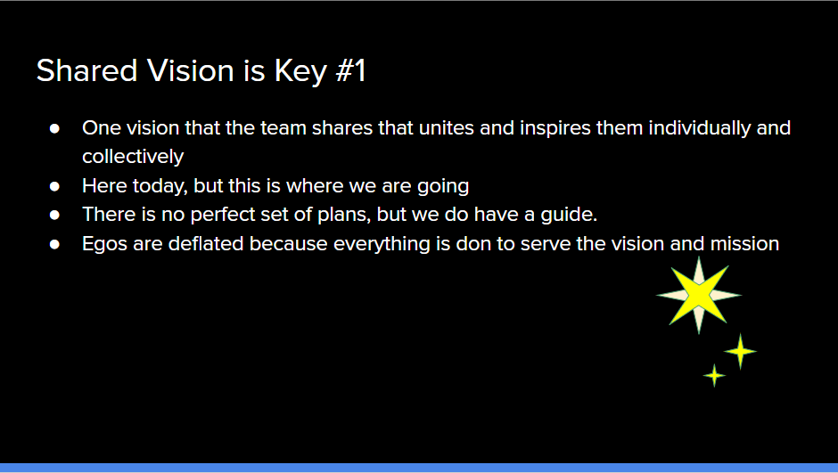

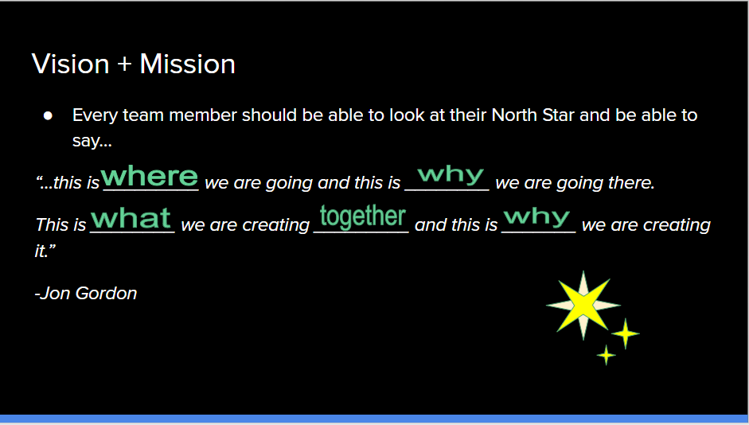

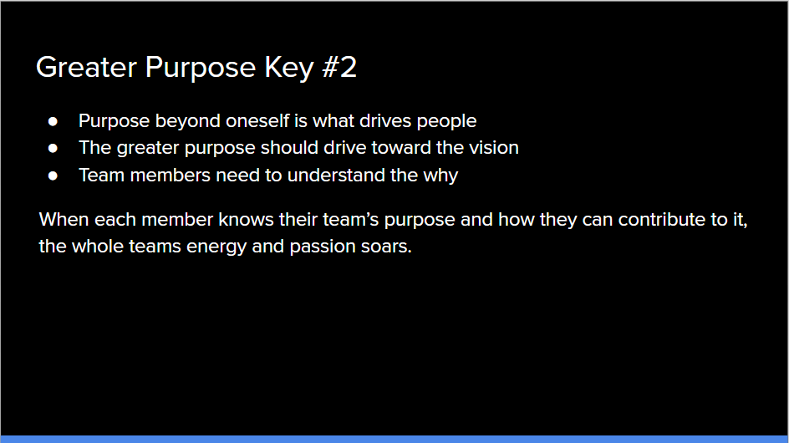

# Positive Teams Work Together toward a Shared Vision with a Greater Purpose

# 

# Shared Vision is Key #1

# 

# Vision + Mission

# 

# Greater Purpose Key #2

# 

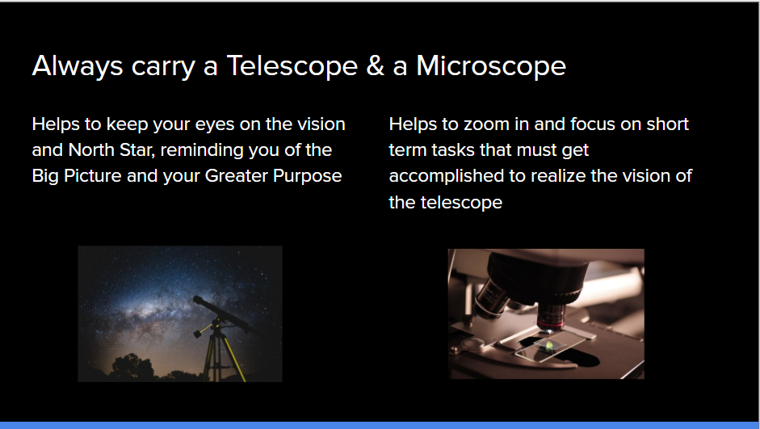

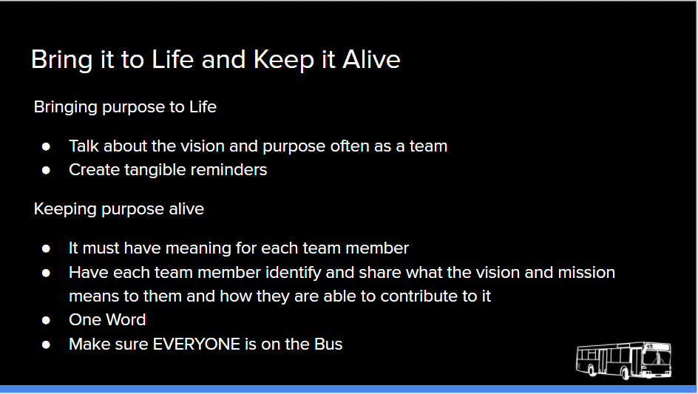

# Purpose-Driven Goals

# Always carry a Telescope & a Microscope

# Bring it to Life and Keep it Alive